1. Write a program in Python to find out the character in a string which is uppercase using list comprehension.

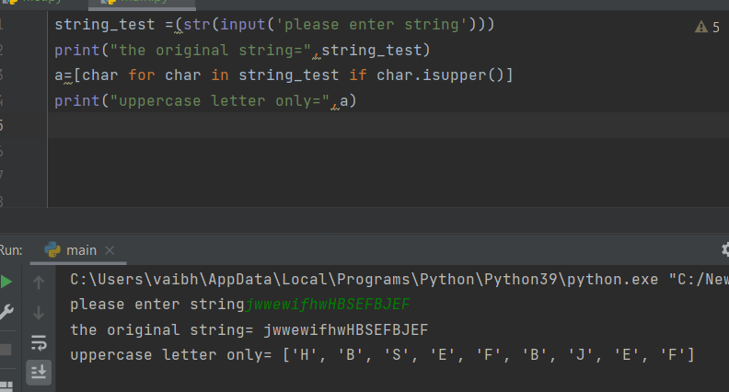

1. Write a program to construct a dictionary from the two lists containing the names of students and their corresponding subjects. The dictionary should map the students with their respective subjects. Let’s see how to do this using for loops and dictionary comprehension.

HINT - Use Zip function also

Sample input: students = ['Smit', 'Jaya', 'Rayyan'] subjects = ['CSE', 'Networking', 'Operating System']

Expected output: {‘Smit’ : ’CSE’ , ’Jaya’ : ’Networking’ , ’Rayyan’ : ’Operating System’}

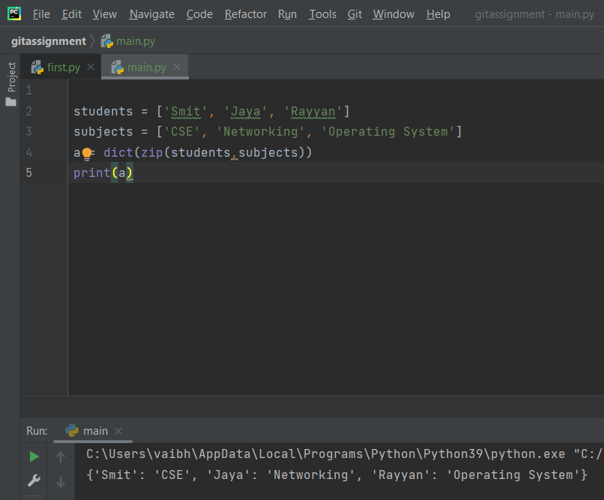

1. Write a program in python using generators to reverse the string.

Input string: “consultadd training”

